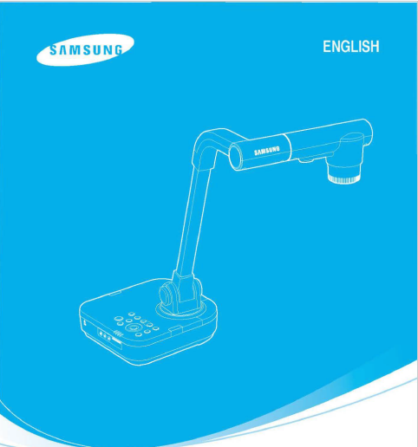
DIGITAL PRESENTER
USER'S MANUAL
SDP-860
Before attempting to operate this product. Please read the instruction carefully.
www.samsungpresenter.com

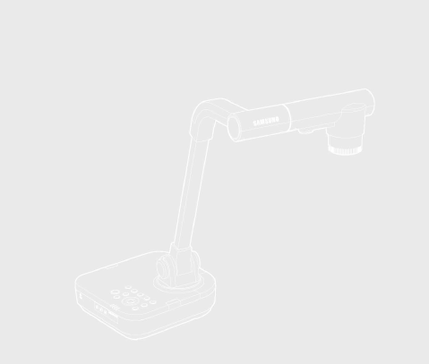

This high-resolution projection system projects images on display devices such as PC monitors and projection screens.

This user manual is for the SDP-860 product. Please read this manual and any supplementary document(s) thoroughly before attempting to install and/or operate the product.

This manual and the software and hardware explained here are protected by copyright law. All copy, reprint and translation to other languages of a part of or all of the contents of this instruction manual without permission of Samsung Techwin Co., Ltd. are expressly prohibited except for fair use within the scope of copyrightlaw.

The specifications of this product are subject to change and upgrade without prior notice.

Product Warranty and Limitations

The manufacturer of this product is not responsible for the sale of the product, nor does the manufacturer delegate such responsibility to a third party. The product warranty does not cover accidents, negligence, abuse, or improper use of the item in whole or in any part. Additionally, the manufacturer does not provide warranty for any additional part or piece that was not supplied by the manufacturer.

The product warranty period is for two years from the purchase date. However, the warranty does not cover any of the following problems, and a nominal service fee will be charged if:

Malfunction due to user's negligence

Dismantling or replacement by the user

Product has been connected to power source that differs from that specified

Malfunction due to natural disasters (fire, flood, tsunami, etc.)

To replace expendable components.

This warranty covers only the product supplied with the warranty.
After the warranty period (two years) has expired, a service fee will be charged for any inspection and/or repair for the product. During the warranty period, a service fee will be charged for repair and/or inspection for the product for any problems that are not covered by the warranty.
This product is not an anti-theft or fire-prevention device; the manufacturer is not responsible for any damage to property or personnel that may occur during its use.

This product must be installed by skilled and experienced personnel; self-installation by the user is prohibited. Self-installation by the user may result in fire, electrocution, and/or product malfunctions. Please contact your local dealer for assistance with the installation of the product.

1300K-Pixel High-resolution & High-Definition Image
Projects a real-time video at 30 frames per second and at 1,300k pixels high-resolution for live presentations.

2D/3D dual Noise Reduction Technology
Equipped with our proprietary ISP chipset and 2D/3D dual noise reduction technology, this projection system depicts vivid colors even in the darkest places.

Ultra-Macro Capacity
With 6x optical and 8x digital zooms , this system achieves a maximum of a 48x combined zoom for an excellent magnification power equal to a microscope. When equipped with an adapter lens, it also delivers ultra-close-up shots.

Convenient Multimedia Options
The SDP-860 not only saves and plays still images and videos (VGA/30 fps) but also supports audio mixing for more versatile multimedia capabilities.

Many Output Device Choices
The SDP-860 supports from XGA lo UXGA for VGA/DVI outputs, offering various choices of output devices.

Table of Contents

Safety Precautions
--------------------------
Warning 6
Caution 7
Product Information
Package Contents 8
Part Names & Functions (Main Frame) 8
Front 10
Back (Rear Connection Terminals) 11
Side (Side Connection Terminals) 12
Part Names & Functions(Main Frame Control Board Remote Controller) 13
Preparing Set 15
Settings Menus & Default Values 18
Installation
Connecting In/Output Devices.... 20
Connecting Output Devices 20
Connecting Peripheral Devices 22
Connecting Computer for External Input 23
Watching Video from External Devices 24
Operation
Basic Operation (Functions) 25
Output Resolution Setup (DVI/VGA output Mode) 25
Enlarging/Minimizing 26
Adjusting Focus 27
Adjusting Brightness 28
Adjusting the Image .. 28
Preset Setting 31
Basic Operation(Operation) 32
Capturing Image & Videos 33
Freeze Mode Setting & Operation 42
Microscope Mode 43
System Reset 44
Checking System Version Information(VER. INFO) 45
Miscellaneous (Appendix)
Troubleshooting 46
Replacing Remote Controller Batteries 47
Product Specifications 55

Safety Precautions
To prevent possible user injury or damage to property, please read and follow all information below.
•

Warning/Caution/Special Mark Messages

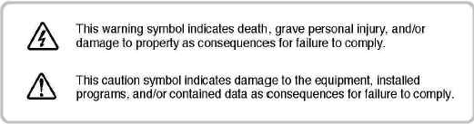

Warning

- Do not connect multiple power cords to a single outlet.
  - It is often the cause of short-circuits that may cause fire.
- Do not place vessels containing water on the product.
- Water leakage can cause serious malfunctions in the product.
- Do not forcibly bend the power cord or place a heavy object on the cord.
  - It may result in fire.
- Do not clean the product with water, paint thinner, or other organic solvent.
  - To avoid product malfunctions and/or electric shock, wipe with a dry cloth.
- Avoid installing the product in places with high humidity.
  - It may result in electric shock and/or fire.
- Do not pull the power cord forcibly off the outlet.
  - A broken cord may lead to fire and/or electric shock.
- Do not disassemble, attempt to fix, or alter the product yourself.
  - There is a risk of malfunction, shock, and other dangers.
- Do not touch the power plug with moisture on your hands.
  - You may receive an electric shock injury.

Caution
- Do not insert the power plug to a loose socket.
- It may result in electric shock and/or fire .
- Avoid installing the product in places that are vulnerable to impact.
- Avoid installing the product in places that are exposed to powerful magnetic fields or vibrations.
- Do not move the product while it is in operation.
- It may damage the product.
- Do not insert or allow foreign objects to enter the product.
- It may damage the product.
- Do not place heavy objects on the product.
- It may damage the product.
- Allow good air circulation around the product.
- Keep the back panel at least 10cm off from a wall and the front panel 5cm away from other devices.
- Avoid installing the product in places that are exposed to direct sunlight or heat sources.
- Install on a flat, stable platform.
- Failure to do so may result in product malfunctions.
- Keep the power plug off when the product is not in use for an extended period of time, or during electrical storms.
- When detecting a strange noise or smell from the product, unplug the power cord immediately and contact our service center for assistance.

CAUTION:
Random replacement of built-in battery by other types of batteries may cause explosion. The battery shall be replaced by the same battery. The used batteries shall be disposed carefully because they can cause environment pollutions.
The picture of the contents may differ from actual products, and certain contents may change if deemed necessary.

Part Names and Functions(Main Frame)
Default Contents
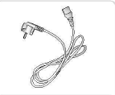
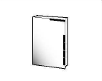
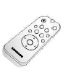
User’s Manual Remote Controller Power Cable

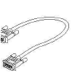
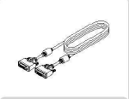
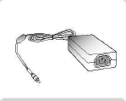

Power Adapter DVI Cable VGA Cable

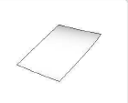
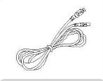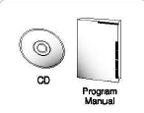

USB Cable USB Program &CD & Manual Diffuser Sheet (290x190)

Accessories 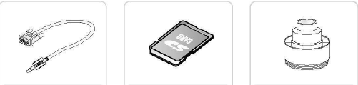
RS232C Cable SD Card Adapter Lens

RS232C cables and adapter lenses from other brands may not be compatible with this product.

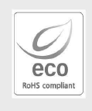
Samsung Techwin cares for the environment at all product manufacturing stages to preserve the environment, and is taking a number of steps to provide customers with more environmentally friendly products.

The Eco mark represents Samsung Techwin's will to create environmentally friendly products, and indicates that the product satisfies the EU RoHS Directive.

Front

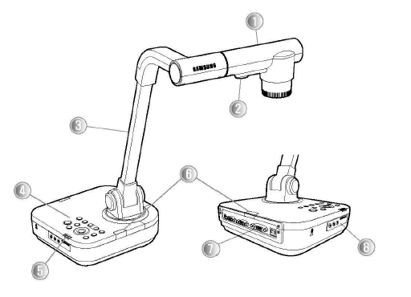

No. | Name
1 | Lens
2 | LED Light
3 | Main Support
4
5 | Status LED
6 | Remote Control Signal Receiver
7 | Rear Connection Terminal (P. 11 )
8 | Side Connection Terminal (P.12)

Mainframe control Board (P. 13)
-.

Back (Rear Connection Terminals)

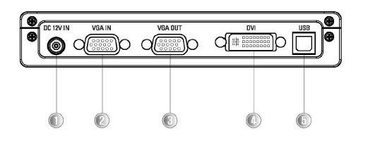

No. | Terminal | Function
1 | 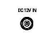 | Connect the power adapter cable.
2 | 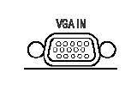 | Connect the video output terminal of a VGA output device. When External Input is selected, video is displayed via this VGA video output terminal. (P. 20)
3 | 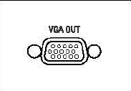 | Connect the RGS video output terminal of a PC monitor or a projector.P. 20)
4 | 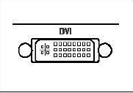 | Connect an LCD monitor or projector that supports DVI  DVII.(P.20)  ..
5 | 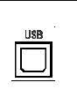 | Use this to connect to USS cable when transmitting image to a PC by USS port (Page 21)

Side (Side Connection Terminals)

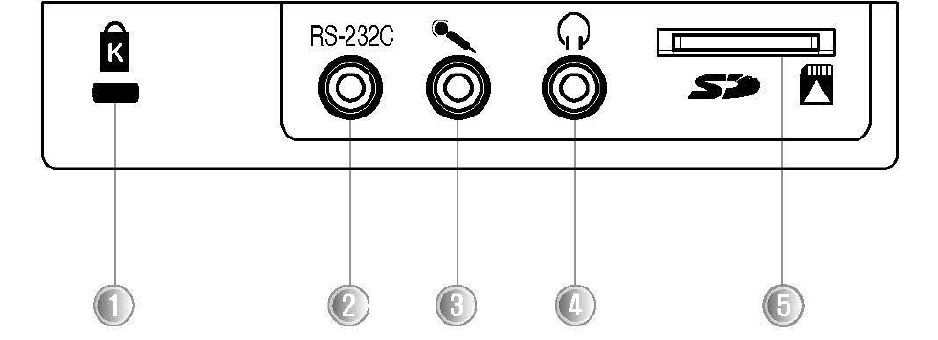

No. | Terminal |  | Function
1 | 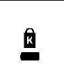 |  | Connect Kensington Security Slot
2 | 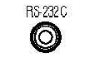 |  | Connect a speaker or earphones for audio  output signals.
3 | 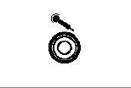 |  | Connect an audio mixing mic for saving videos. .....
4 | 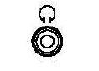 |  | Connect an RS-232C cable. .....
5 | 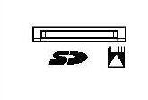 |  | Connect an SD/SDHC card for saving or importing videos and pictures.

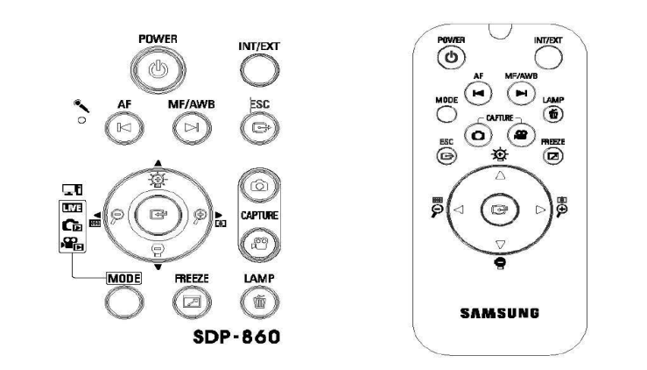
No. | Button | Function
1 | 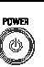 | Turn On/Off Power
2 | 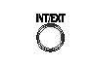 | Select Internal/External Video .
3 | 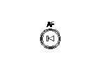 | ( LIVE Mode) Auto Focus  (While Playing Video) Play Previous File  (Capture/LIST Mode) Page DOWN
4 | 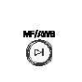 | (LIVE Mode) MF/Auto Color Adjustment  (While Playing Video) Play Next File  Capture/LIST Mode) Page UP
5 | 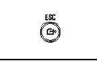 | Cancel Command

No. | Button | Function
6 | 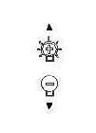 | ( LIVE Mode) Brighten/Darken Screen  (While Playing Video) Adjust Volume -..  (Capture/LIST Mode) Move Up/Down
7 | 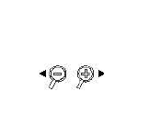 | ( LIVE Mode) Enlarge/Minimize Screen  (While Playing Video) Rewind/Fast Forward.  (Capture/LIST Mode) Move Left/Right. Page 26
8 | 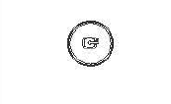 | ( LIVE Mode) Open Menu  (Capture/LIST Mode) Execute Selected Menu (While Playing Video) Play/Stop
9 | 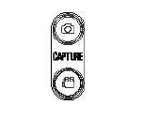 | File (SD Card Required) -.  ( LIVE Mode) Capture Screen as Picture/I Video. Page 32
10 | 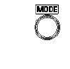 | Switch to LIVE, Picture , or Video Mode  (Picture and Video Modes Require SD Card )
11 |  | ( LIVE Mode) Pause Screen  (While Playing Video) Switch to Full Screen.  Page 39
12 | 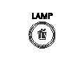 | ( LIVE Mode) Tum On/Off Light  (Capture / LIST Mode) Delete Picture & Video
13 | 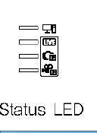 | In LIVE Mode, Blue LED  In Still Image Mode, Blue LED  In Video Mode, Blue LED  In External Mode, Blue LED

C:

-

- Face the lens straight down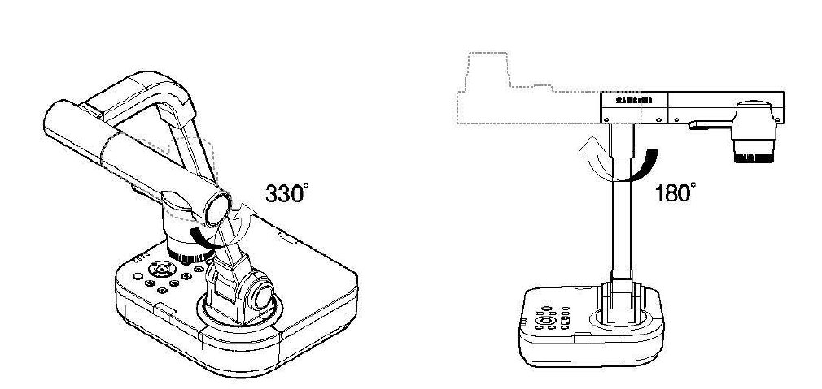
- Adjust the main support to face the lens toward a document

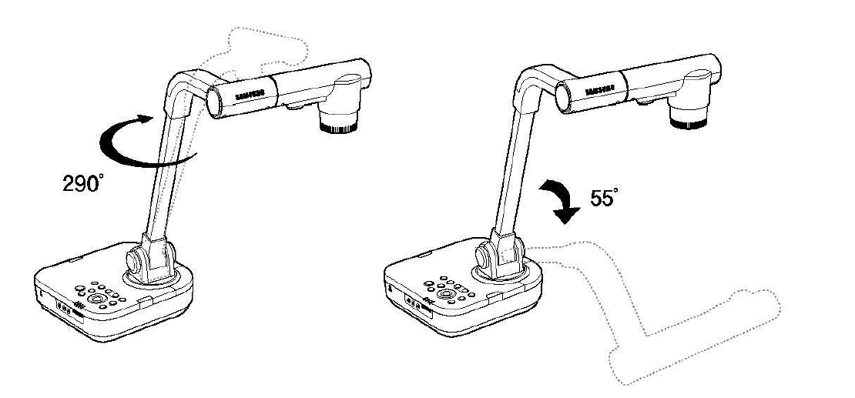

- Connect a VGA OUT, DVI, or USB cable and the power cord. (P.20)

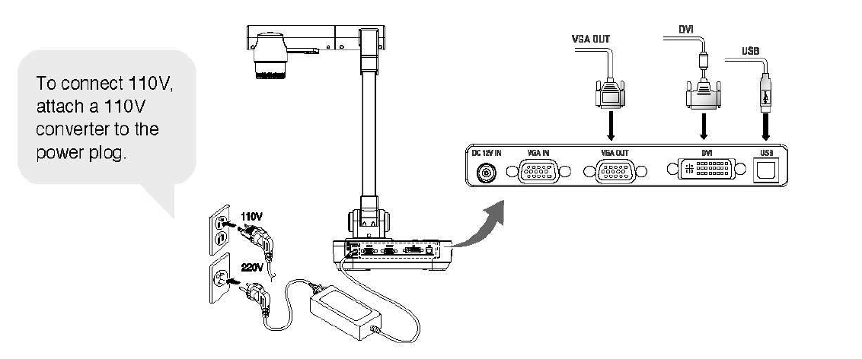........... ····
- To turn on the power of the digital presenter, press the Power button on the digital presenter's control board or remote controller.
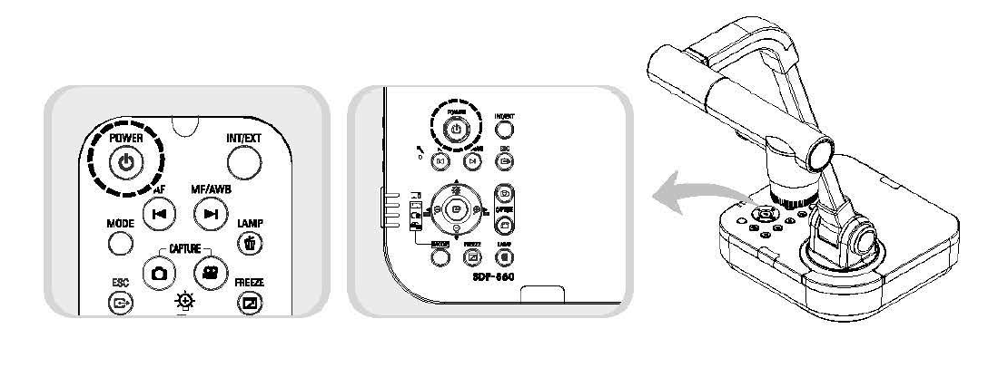

- Pressing the Power button turns on the LIVE power LED light around the button and set status LED in blue.
- Initial Screen
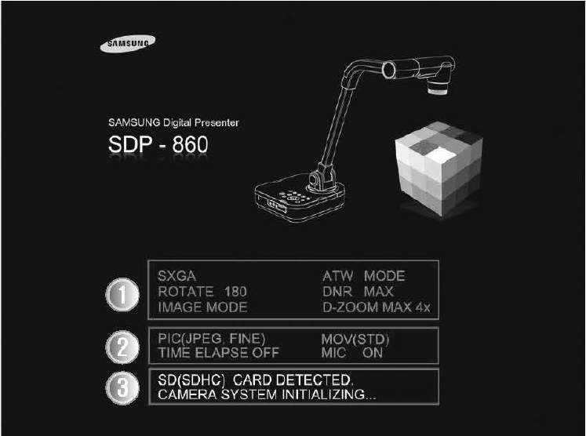

Displays the current digital presenter settings.
- Displays the current screen-capture settings.
- Displays the operational status of an SD card and the system.
- SD (SDHC) CARD DETECTED: An SD card is inserted.
- SD (SDHC) CARD DOES NOT EXIST: No SD card is inserted.
- CAMERA SYSTEM INITIALIZING In the process of initializing the system
- SYSTEM FIRMWARE FILE EXISTS System update files are available in an inserted SD card.
- PLEASE WAIT FOR UPDATE PROCESS: In the process of updating the system
- UPDATE PROCESS DONE!: The system is updated.

I | II | III | IV | Default Values/ States
Output resolution settings | SXGA 1280X1024 43  UXGA 1600X1200 4:3 Up-Scaled  XGA 1024x768 4:3 Down-Scaled SXGA  720p 1280x720 16:9 Window Cut-out  1080p 1920x1080 16:9 Window Cut-out  720p 1280x720 16:9 Stretched  1080p 1920x1080 16:9 Stretched
 | WB Mode | ATW (tracking)/AWB (One Push)/ Manual |  | ATW
 | DNR | OFF/AUTO(DYNAMIC SCENE)/MAX(STATIC SCENE) |  | AUTO
 | ROTATION | 0/180 |  | 0
IMAGE ADJUSTEMENT (Image Adjustment) | IMG Mode | TEXT
IMAGE ADJUSTEMENT (Image Adjustment) | IMG Mode | IMAGE
IMAGE ADJUSTEMENT (Image Adjustment) | IMG Mode | CUSTOM | Tone – Very LOW/LOW/Normal/ HIGH/ Very HIGH  COLOR – LOW/MIDDLE/HIGH/BW  SHARPNESS – LOW/MIDDLE/HIGH | TEXT

SETUP MENU
 | II | III | IV | DEFAULT VALUE/STATE
Enlarge/Minimize (ZOOM/FOCUS) | Manual Focus  MACRO Mode  MICROSCOPE Mode |  |  | -
Enlarge/Minimize (ZOOM/FOCUS) | D-Zoom | Off/4X/8X |  | 8X
Screen Capture (CAPTURE SETTINGS) | MAX  PIC  Format  JPG Quality  MOV Quality | JPEG/BMP  FINE/NORMAL/BEST  STANDARD/BEST |  | JPEG  NORMAL  STANDARD
Screen Capture (CAPTURE SETTINGS) | Mic Mute  Time Elapse  Reset File Number  Preset EXE | ON/OFF  OFF/5min/10min/15min/20min/30min/45min/1h  --PRESENT1/PRESENT2/PRESENT3/PRESENT4 |  | OFF  OFF  -  -
Preset Settings (PRESET SETTINGS) | Preset SAV  BOOT Preset  Freeze | PRESENT1/PRESENT2/PRESENT3/PRESENT4  OFF/ PRESENT1/PRESENT2/PRESENT3/PRESENT4  DVI,VGA/ONLY DISPLAY |  | -  OFF  DVINGA

Connecting Input and Output Devices

Connecting Output Devices

To use a normal or DVI monitor, you must connect the monitor to the digital presenter using a monitor or DVI cable.

Connection

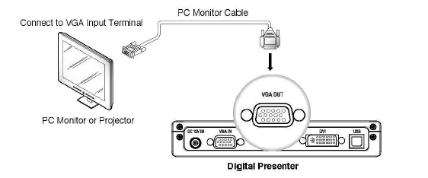

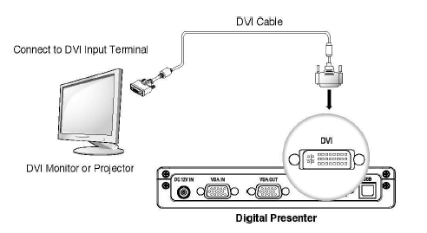

* Depending on the specifications of the SDP-860 D/A converter and the monitor A/D converter, the color of RGB and DVI outputs may vary.

Connecting Computer for Output

You can watch projected images on a PC monitor by connecting the PC to the digital presenter via USB cable.

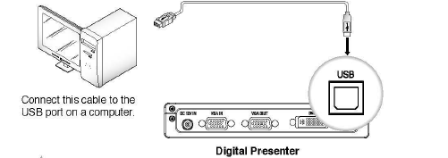

CAUTION:

For the USB cable connection, using a USB port on the main board of a computer is recommended. (Using an extended front port or wireless USB hub may cause errors depending on the computer brand and model.)
Please do not use a USB cable longer than 4.0m for the connection between the projector and a computer.
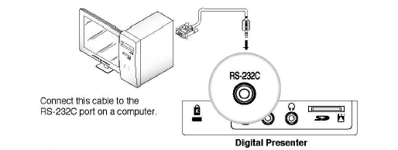

CAUTION:

A RS-232C cable is not included in the product package ; please purchase it separately. RS-232C cables from other brands may not be compatible with this product.
- When connecting via USB, install the included USB drivers and SDP-860 Viewer program in your computer. For instructions on installing the software, please read the manuals. For connecting via RS-232C cable, no extra program is provided; install and use an appropriate program.

Connecting Peripheral Devices

Connecting SD/SDHC Storage Device
- You can connect an SD/SDHC card for data storage. Hold an SD card with the metal tip (golden finger) facing upward, and then insert to the projector.
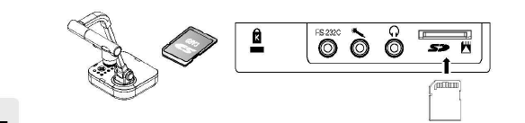
- The "SD Card Detected" message displays on the screen. Once the card is ready to use, the Picture and Video Capture menus become available

CAUTION:
If the SD card is locked, the Video Capture menu cannot be used.
* An SD/SDHC card is not included in the product package; please purchase ii separately. MMS cards are not supported .

Connecting Audio/Mic
Audio and mic use the 3.50 terminal.

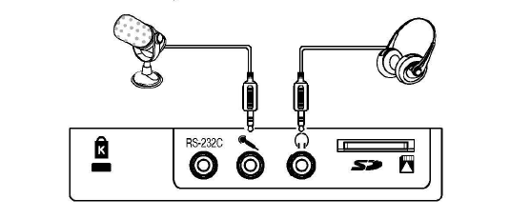Connecting Kensington Security Slot
Kensington Security Slot is an anti-theft system that is integrated to the projector. Wind Kensington Security Cable around a fixture apparatus such as a rack , and then insert the end of the cable to the Kensington Security Slot in the projector.

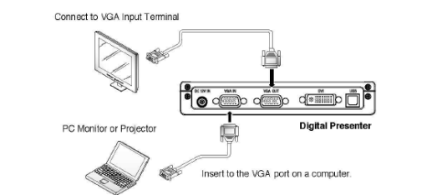
CAUTION:
Kensington Security Cable is not included in the product package; please purchase it separately.

Connecting Computer for External Input
To watch VGA videos on a PC monitor, connect the digital presenter to the computer using the computer monitor cable.
* DVI Output does not support this option.
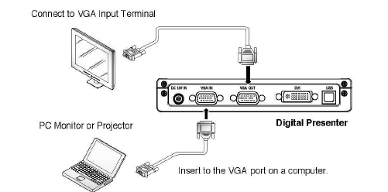
-

Note
Bypass Option: Turn on the power of the digital presenter to output video from the VGA IN terminal to VGA OUT.

Basic Operation Functions

Watching Video from External Devices
Install the digital presenter as instructed in this manual. (PAGE 15)

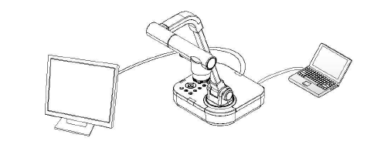
Select an Input option; press (in/text)on the digital presenter control board or remote controller to select an input.
-

External input or digital presenter video switches back and forth each time the button is pressed.
External Input Video [Ext]
Enables watching video from an external VGA generator on a connected PC monitor or projector.

Digital Presenter Video [Int]
Select to watch video directly from the digital presenter lens.

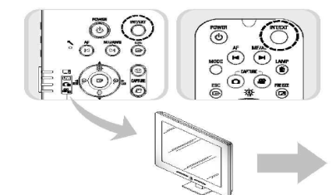

CAUTION:
If an external input device is not connected. The output device displays only the black screen. In this case, check if the external input device is connected properly.
Selecting the INT or EXT button does not display the current input status on the screen.

Output Resolution Setup(DVINGA Output Mode)
Various output resolutions are available depending on the output device: monitors or projectors.
Available resolutions are as listed below.
- SXGA (1280x1024)
- UXGA (1600x1200 )
- XGA (1024 x768)
- 720p (1280x720)
- 1080p (1920 x1080)
- 720p (1280x720)
- 1080p (1920x1080)

- . Select DVI/VGA OUTPUT in the Menu.

- To select a resolution, move the cursor( ) between resolutions in the sub menu.
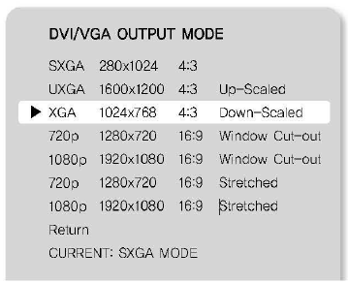

Caution:
A resolution may not be available if an output device (monitor or projector) does not support it

Enlarging/Minimizing

- You can zoom in and out on screen objects.
- To enlarge or shrink, press the (Enlarge) or (Minimize) button on the control board or remote controller (6x Optical Zoom & 8x Digital Zoom).
- When using the Enlarge and Minimize buttons, the blue gauge indicates the optical zoom portion while the red indicates digital.
- Holding down on the Enlarge button no longer enlarges an object once the 6x optical zoom gauge is at 6x. To zoom further with the digital zoom , press the
- Enlarge button once more. This also applies to zooming out on an object; to zoom out from the digital to optical zoom , press the Minimize button once more.
- Using the digital zoom may cause the degradation of image quality.

Macro Mode

- You can capture documents from extremely close ranges within 1cm to 5cm.
- In the Menu, select ZOOM/FOCUS > MACRO Mode.

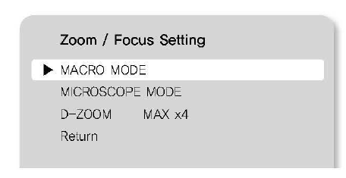
- To check the mode availability, press the AF button 1 to 5cm away from a document.
-
- Cancels the Super Macro Mode.
- In Macro mode, the optical zoom is disabled and only the digital zoom works.

Maximizing Digital Zoom (D-Zoom Max)

You can select a maximum digital zoom power.
In the Menu, select ZOOM/FOCUS > D-ZOOM MAX.
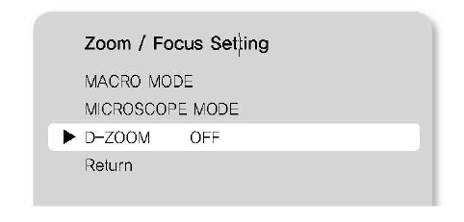
- Pressing the Zoom in and Zoom out button changes the maximum zoom power to OFF > 4x > 8x.
- After selecting a D-ZOOM MAX value, press the main unit key in Live mode to check if the zoom value has been applied.

Adjusting Focus

- You can auto focus on the Live mode screen
- To auto-focus, press the AF button on the control board or remote controller while in Live mode.

Manual Focus
- You can manually focus on the Live mode screen.
- Press the MF/AWB button and then to focus on the screen.
- Press MF/AWB to finish.

Adjusting Brightness
- You can use the lens iris to adjust the brightness of an object; if the object is too dark, brighten it, and if it is too bright, darken it.
- To brighten: Press on the control board or remote controller.
- To darken: Press  on the control board or remote controller.

Note
- For glossy paper documents, turn off the upper light to use only natural light. For
- better visual quality, use 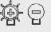 or the remote controller's Darken button to lower the brightness, and then adjust the position of the document.

Adjusting the Image

(White Balance)
- You can automatically adjust the color of the Live mode screen.
- In the Menu, select IMAGE ADJUSTMENT > WB Mode.
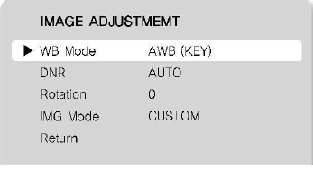
- Pressing the button changes the While Balance mode lo ATW (Auto Tracking) > AWB (KEY) > MANUAL WB.
- Auto Color Adjustment Method 1: AWB (KEY)
- Automatically adjusts the color of the Live mode screen.
- Select AWB (KEY), and then press the MF/AWB button on the Live screen.

Operation (Functions)

Select AWB between MF and AWB.

SELECT FUNCTION

AWB - SET(AWB KEY)
MANUAL FOCUS
CANCLE

- Press MF/AWB to adjust the color automatically.
- Save the settings and then exit to the Live screen.
- Auto Color Adjustment Method 2: ATW (Auto Tracking)
- Automatically adjusts WB mode when the color temperature of a light source changes.
- Select ATW (Auto Tracking).
- Save the settings and then exit to the Live screen.
- How to Adjust Color Manually
- Adjust the RED and BLUE gains manually to adjust the WB mode.
- Select MANUAL WB.
- Use the Up, Down, Left, and Right buttons to select a value.
- Save the settings and then exit to the Live screen.

Noise Reduction (DNR)
- DNR stands for Digital Noise Reduction that uses 2D/3D noise filtering to achieve clear images.
- In the Menu, select IMAGE ADUSTMENT > DNR.
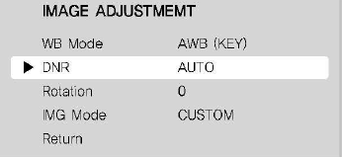
- Pressing the button changes the Noise Reduction mode to OFF > AUTO> MA X.
- AUTO: Automatically controls the NR amount depending on the lighting conditions.
- MAX: Always keep the maximum NR amount
*
- Selecting Auto may cause after images if there are many movements on one screen.

(Rotating Image)
- You can rotate images on the screen.
- In the Menu, select IMAGE ADJUSTMENT > Rotation

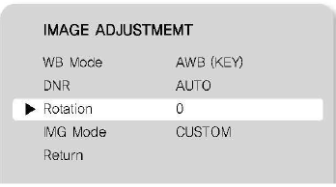
- Pressing thebutton brings up a screen that rotates an image from O' to 180' .
- While rotating, press Screen Capture to save the image at the current rotation angle.

Image Outline Adjustment (IMG Mode)
- This mode optimizes visual quality according to projection types.
- In the Menu, select IMAGE ADJUSTMENT > IMG Mode.
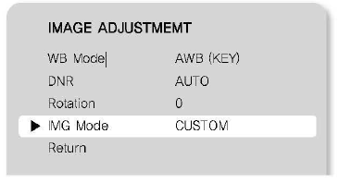

- Pressing the button changes to TEXT > IMAGE > CUSTOM.
- TEXT Mode: Optimizes the screen for documents with dense text.
- IMAGE Mode: Optimizes the screen for pictures and videos.
- When selecting CUSTOM Mode, the following sub menus appear.
- TONE: Changes the gamma value of luminance. Pressing the button changes to Very LOW> LOW > NORMAL > HIGH > Very HIGH.
- COLOR: Change the gain. Pressing the button changes to LOW > MIDDLE> HIGH.
- SHARPNESS: Changes the sharpness of images (outline adjustment value).
- Pressing the button changes to LOW> MIDDLE > HIGH.

Preset Setting
- You can save zoom and focus positions and brightness levels as presets.
- In the Menu, select PRESET SETTING.

PRESET SETTING
-

Preset EXE Preset1
- Pre-SAV Preset1
BOOT PRESET OFF
Return

P1: z: - 11, F:1271, B:60
P2: z: - 11, F:1271, B:60
P3: z: - 11, F:1271, B:60
P4: z: - 11, F:1271, B:60

- Select Preset-SAV, and then press thebutton to enter the current settings to a preset number.
- To check the availability of the number, whether or not the number already contains a preset, select Preset-EXE in the menu, and then press thebutton.
- The BOOT Preset menu automatically applies saved settings when turning on the projector.
- Up to 4 presets can be saved.

Capturing Images & Videos

(Capture)
For screen captures, the image format and resolution can be configured.
In the Menu, select CAPTURE SETIING.
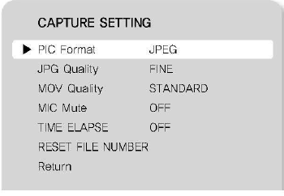
- Selecting capturing Image Format (PIC Format)
- Press the button to select a desired resolution. Still image resolutions change to JPEG>BMP.
- Press the button to select a desired resolution. Still image resolutions change to FINE> NORMAL > BEST.
- Selecting Video Resolution (MOV Quality)
- Press the button to select a desired resolution. Video resolutions switch between STANDARD> BEST.
- Enabling Mic (MIC Mute)
- Press the button to use the Mic Mute option: OFF or ON.
- Time Elapse Setup (TIME ELAPSE)
- Press the button to select a video recording duration from 5 minutes to 1 hour.
- Resetting Filename (RESET FILE NUMBER)
- Resets the filename of an image or video capture.

Caution: If an inserted SD card contains the same filename, the old file may be deleted. Please back up the SD card data before using this option.

Press the  button to reset the filename of an image or video capture.

Operation (Functions)

Capturing Images
- Install the digital presenter as instructed in this manual.

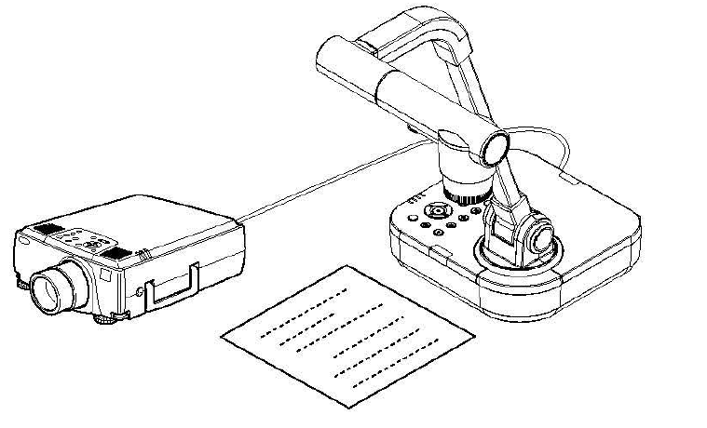

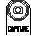
- Insert an SD card.
- To capture an image, press the button on the control board or remote controller.
- Once the image is captured, the screen goes back to Live
mode. 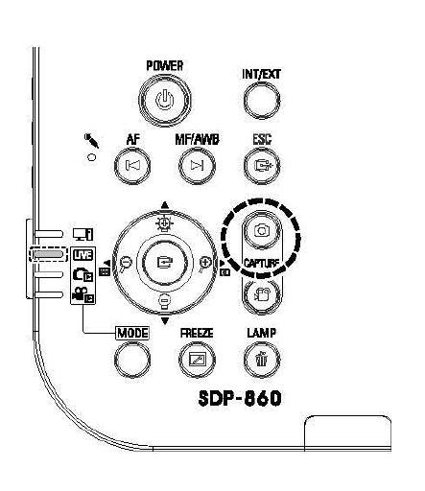

To check the captured image, press the MODE button to enter Picture List mode.

5. Picture List Mode: 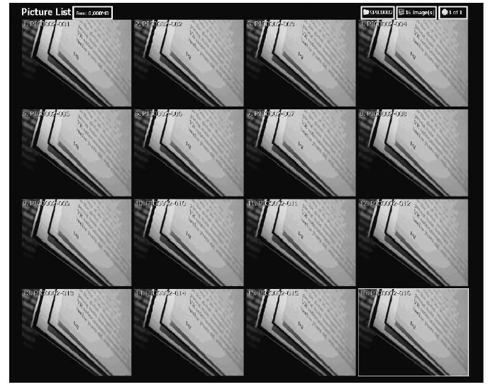

Screen Description
-
- Indicates remaining free space of the current SD memory card.
- Indicates the current folder name.
- Indicates the number of images in the current folder.
- Indicates the current page and total pages in the current folder.

6. Press the buttons to select an image.
(To move between pages, use the buttons)

Operation

- Press 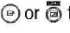 to check the captured image.
- Full Screen
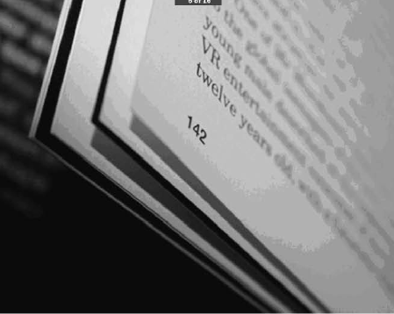

- While in full screen mode, use the Left and Right keys to move between images.
- The AF button moves to the first file in the folder. The AWB button moves to the last file in the folder
- To exit full screen to Picture List mode, press the button.
- To delete an image, select the image, and then press

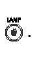

Capturing Video
- Install the digital presenter as instructed in this manual.
- To record audio, connect a mic.

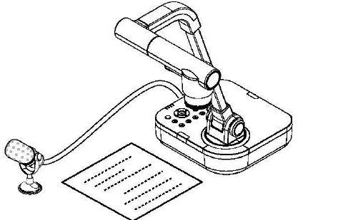
- When the control board or remote controller is turned on, the projector activates LIVE mode (LIVE).

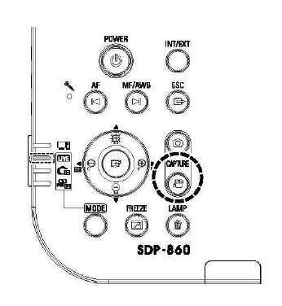

- Insert an SD card.
- To capture video, press the button on the control board or remote controller.
- While capturing video, the filename and running time display on
the bottom of the screen.
- If the video recording duration (TIME ELAPSE) is set, the remaining time displays instead of the running time.

- To finish capturing and go back to Live mode, press the MODE button.
- To finish capturing and check the captured video, press the C) button and enter Movie List mode.

- Movie List Mode

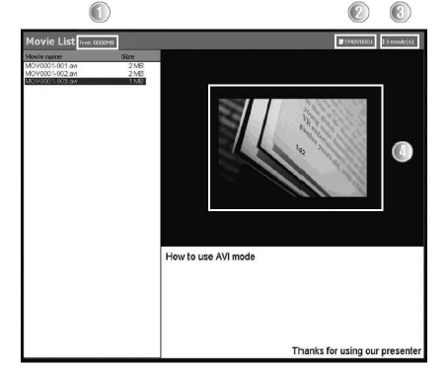

-
- Indicates remaining free space of the current SD memory card.
- Indicates the current folder name.
- Indicates the number of videos in the current folder.
- Indicates the thumbnail of a selected video.

- Press the buttons to select a video.
- (To move between pages, use the buttons.)

- Press to play the captured video.
- Playback Screen

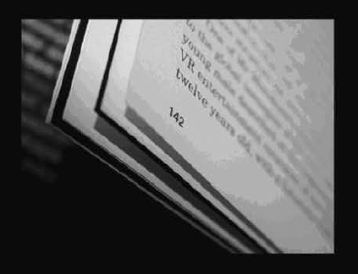
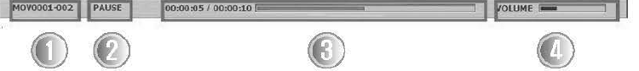

Video is played at the original 640x480 size.
-
- The Left and Right keys play video 1o seconds forward or backward.
- To stop playing and go back to the Movie List, press the ® button.
- Screen Description
- The file that is currently being played
- Playback Status (PLAY/ PAUSE)
- Video Running Time
- Volume
- For the playback screen controls, refer to Control Board/Remote controller functions.
10. To delete a video, select the video, and then press .

Freeze Mode Settings & Operation
In the Menu, select ZOOM/FOCUS > MICROSCOPE Mode.

The Freeze button pauses only video that is connected to a DVI/VGA output. II also plays external video, connected via USB, on the Live screen.
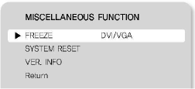

Caption: When capturing video, the Live screen is captured, not the Freeze screen.

ONLY DISPLAY Mode:
- The Freeze button pauses videos that are connected both from a DVI/VGA output and via USB.
- When video, the Freeze screen is captured.

Microscope Mode
- Attach a microscope adapter lens to the digital presenter lens part.

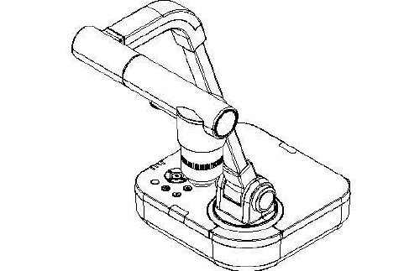
- Bring the microscope adapter lens to the ocular part of the microscope that is properly focused, as close as possible. Adjust the position of the digital presenter to bring the circular image of an object in the center of the monitor.

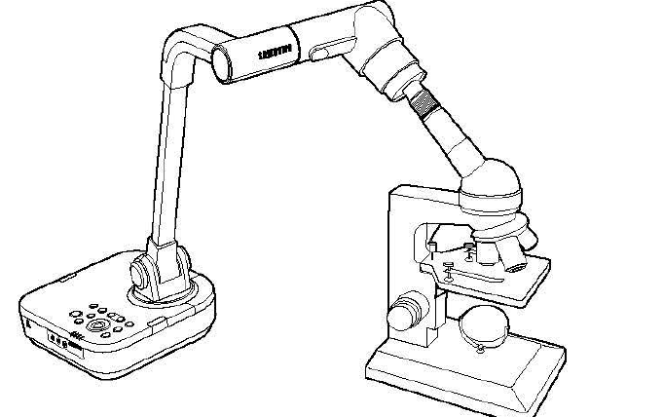

- In the Menu, select ZOOM/FOCUS > MICROSCOPE Mode.

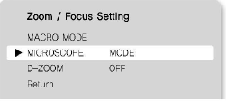

- Check if the screen is focused properly. If not, adjust the micromanipulator of the microscope to refocus. Check if the screen is now focused.

- To cancel Microscope mode, press the ® button.

* Ultra Macro Mode: -

When used in conjunction with an adapter lens, the projector can capture the screen at an extremely close range within 1cm.

System Reset
- Resets all current settings.
- In the Menu, select SPECIAL FUNCTION> SYSTEM RESET.

- This System Reset menu automatically executes Reset File Number under the Capture Settings. Please back up your SD card data before using this.

Press the button to reset the system.

Checking System Version Information (VER. INFO)
'C

- Displays the current system version of the product.
- In the Menu, select SPECIAL FUNCTION> VER.INFO.
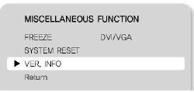

TROUBLESHOOTING

Error  Video doesn't display. | Solution
Error  Video doesn't display. | Please make sure that the resolution of the projector and product main unit are matched. (e.g. If the projector 's resolution is set to the maximum SVGA while the main unit is XGA or SXGA, the screen cannot display video.  Check if the output device is connected with a proper input type.  Check if the screen is properly adjusted for brightness and focus.  Page 25
The projector doesn't communicate with a PC when connected via USB. | Check if the PC is installed with the SDP-860 program properly.  Check if the PC operating system is Windows XP or higher. Older versions of the operating system may cause operational errors.  For more detailed information about the SDP-860 program, please refer to the included manual.
The remote controller doesn't work. | Check the remote controller's batteries. Replace with new ones if necessary.  Page 43

'I

Replacing Remote Control Batteries
- Remove the battery lid on the back of the remote controller.

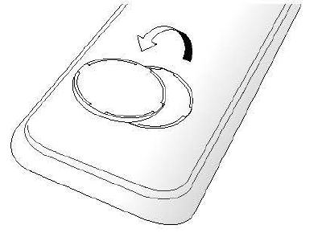

- Insert batteries matching the + and - signals. (Battery Type: CR-2025)

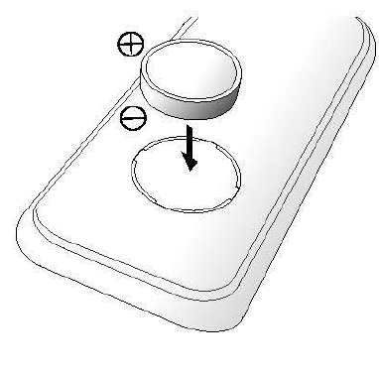

- Close the lid.
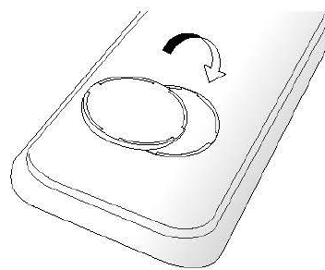

Caution: Random replacement of built-in battery by other types of batteries may cause explosion. The battery shall be replaced by the same battery. The used batteries shall be disposed carefully because they can cause environment pollutions.

The following specifications are subject to change and upgrade without prior notice.

White Balance |  | ATW / AWC (One-touch ) / Manual
Aperture Function |  | Image Mode /Text Mode/ Custom Mode
Noise Reduction |  | Available (Low Light presenter with 2D/3D NR)
Preset Function |  | Up to 4 User settings
Image Freeze |  | Available
Image Rotation |  | Available(180 degree)
Image Save | Photo | MPEG-4 640 x 480@30fps with Audio (Mic)
Image Save | Movie | SDHC card (Up to32GB)
Image Playback | Photo | 4 X 4(16 Split)
Image Playback | Movie | Internal Movie Player
USB |  | USB 2.0
Input Selection |  | 2 Channels (Internal: 1, External: 1)
Illumination |  | LED Illumination System
Input Port | VGA In | 15 Pin DSUB Connector x 1
Input Port | Audio In | ᶲ3 . 5 Jack x 1 (Built-in Microphone)
Output Port | VGA Out | 15 Pin DSUB Connector x 1
Output Port | DVI Out | DVI Connector x 1
Output Port | Audio Out | ᶲ3.5 Jack x 1
1/F Port | RS-232C | ᶲ3.5 Jack x 1
1/F Port | USB | USB B-type x 1
1/F Port | Memory | SDSlotx1
Power Port |  | 12V DC In x 1
SDP-

Lens | F = 2.5(Wide)-3.12(Tele), f = 4.1- 24.6mm, 6X Zoom Lens
Shooting Area | Max: 420 x 336 mm
Zoom | 48X Zoom(Optical 6X / Digital 8X)
Focus | Auto focus/ Manual
Iris | Auto (with fine level adjustment)

Pick-up Device | 1/3" PS CMOS Sensor
Total Number of Pixels | 1,384(H) x 1,076(V), 1.49M pixels
Number of Effective Pixels | 1,329(H) x 1,049(V), 1.39M pixels
Frame Rate | SXGA: 30fps
VGA Output | SXGA (1,280 X 1,024), XGA (1,0 24 x 768 ), UXGA (1, 600 x 1, 200),HD (1028 x 720p) Full HD (1,920 x 1,0BOp)
Resolutions | H: 700 TV Lines/ V: 700 TV Lines
Operating Temperature |  | +5· c ~+35'c
Operating Humidity |  | 30%~90%
Power |  | 12V DC ( Adaptor Input: 1OOV AC - 240V free voltage, 50/60Hz, Output: 12V, 4A)
Dimensions |  | In-use 374(W) x 449(H) x 431(D)mm / 14.72"(W) x 17.68"( H) x 16.9 7"(D)mm
Weight |  | 3. 7kg (8.161b)
Supplied Accessories |  | Remote Controller, USB cable, DVI cable, VGA cable
Accessories | Optical Accessories | Microscope adaptor lens RS-232C cable, SD card

'16

'17

SAMSUNG TECHWIN

SAMSUNG TECHWIN CO., LID
HEAD OFFICE: SAMSUNG TECH WIN CO., LTD
145-3 Sangdaewon 1-Dong, Jungwon-Gu, Sungnam, Kyungki-Do ,Korea 462-703 TEL · 82-31-740-8137-8141 FAX : 82-31-740-8145
U.S.A OFFICE: SAMSUNG OPTO-ELECTRONICS AMER ICA, INC.
40 Seaview Drive, Secaucus NJ 07094, U.S.A TEL . 201-902-0347 FAX: 201-902-0429
SAMSUNG TECHWIN MOSCOW OFFlCE
LENNINGRADSK Y PR-KT, 37-A KORP.14 RUSSIA, 125167, MOSCOW TEL: +7-095-2 58-9296, 9298 FAX: +7-095-258-9297
SAMSUNG OPTO-ELECTRONICS UK LTD (SOUK)
Samsung House,1000 Hillswoo d Drive Hillswood Business Park Chertsey Surrey KT160PS TEL 44-(0)1932-45-5308 FAX 4 4-(0)1932-45-5325
TIANJIN SAMSUNG OPTO-ELECTRONICS CO.,LTD (TSOE)
7 Pingchang Rd,Nankai Dist,Tianjin,P.R China Post Code :300190 TEL :86-22-2761-9698 FAX :86-22-2761-6514

www.samsungtechwin.com
www.sasmsungpresenter.com P/No: 6806.1086.01A

